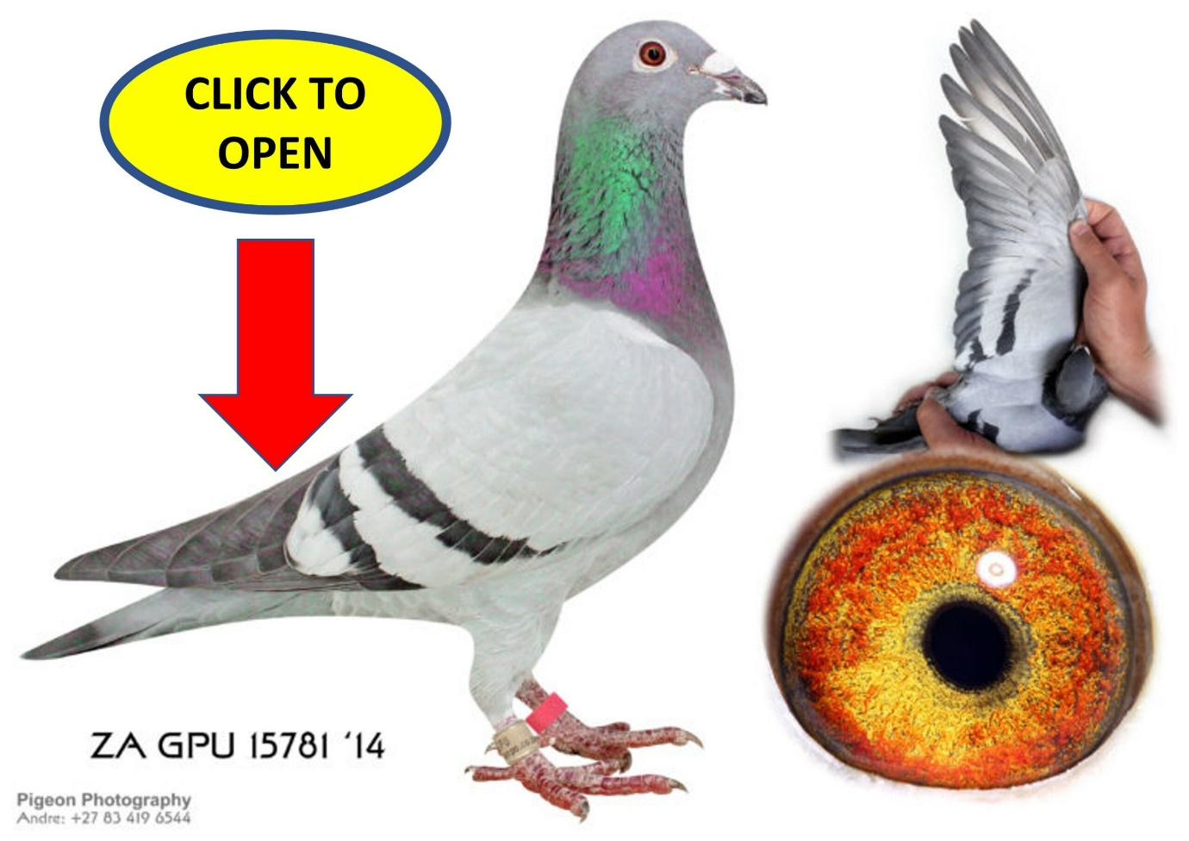

5 X WINNER PLUS FEDERATION WINNER
GOLD MEDAL WINNER SANPO MIDDLE DISTANCE 2016
SILVER MEDAL WINNER SANPO OVERALL 2016
ACE BIRD OVERALL GAUTENG COMBINE 2016
ACE BIRD OVERALL T.R.P.F 2016
ACE BIRD OVERALL MIDDLE DISTANCE GAUTENG COMBINE 2016
ACE BIRD OVERALL MIDDLE DISTANCE T.R.P.F 2016
ACE BIRD OVERALL DIVISION 3 2016
ACE BIRD OVERALL S.R.P.C 2016
ACE BIRD OVERALL MIDDLE DISTANCE S.R.P.C 2016
ACE BIRD OVERALL SHORT DISTANCE S.R.P.C 2016
7TH BEST BIRD SHORT DISTANCE T.R.P.F 2016
3RD BEST BIRD SHORT DISTANCE DIVISION 3 2016
2ND BEST BIRD MIDDLE DISTANCE DIVISION 3 2016
27TH BEST BIRD LONG DISTANCE DIVISION 3 2016
9TH BEST BIRD LONG DISTANCE S.R.P.C 2016
14TH BEST BIRD SHORT DISTANCE GAUTENG COMBINE 2016
16TH BEST BIRD MIDDLE DISTANCE GAUTENG COMBINE 2016
110TH BEST BIRD LONG DISTANCE GAUTENG COMBINE 2016
66TH BEST BIRD LONG DISTANCE T.R.P.F 2016
THIS HEN FLEW THE FOLLOWING POSITIONS IN THE GAUTENG COMBINE
3e combine Cradock 709km with 5823 birds
8e combine Smithfield 475km with 7358 birds
9e combine win burg 2 284km with 7908 birds
37e combine springfontein 514km with 6729 birds
166e combine Bloemfontein 386km with 7857 birds
234e combine Bloemfontein 2 386km with 7661 birds
704e combine win burg 4 284km with 7795 birds
1930e combine tromps burg 2 485km with 6694 birds
THIS HEN FLEW THE FOLLOWING POSITIONS IN THE T.R.P.F
1e Club 1e Div 1e Fed Alwal North 525km 1588.847mpm
1e Club 1e Div 3e Fed Cradock 709km 1172.453mpm
1e Club 2e Div 4e Fed Dewetsdorp 404km 1464.544mpm
1e Club 2e Div 5e Fed Springfontein 514km 1131.127mpm
1e Club 3e Div 21e Fed Bloemfontein 386km 1197.224mpm
2e Club 7e Div 9e Fed Winburg 284km 1476.017mpm
3e Club 4e Div 7e Fed Smithfield 475km 1434.617mpm
3e Club 4e Div 11e Fed Colesberg 585km 1318.303mpm
14e Club 39e Div 93e Fed Bloemfontein 4 385km 1708.396mpm
THIS HEN IS ALSO THE MOTHER TO 3 FEDERATION WINNERS AND A
2ND FED 2ND COMBINE WITH DIFFERENT COCKS
ZA TRPF 8065-18 WINBURG 4 SPRINTS 281KM 1425.025MPM
ZA TRPF 19011-17 WINBURG 5 SPRINTS 281KM 1316.786MPM
ZA TRPF 21025-16 CRADOCK 4 708KM 1406.014MPM
ZA TRPF 21025-16 ALSO GOT 2ND COMBINE FROM SPRINGFONTEIN 513KM 1372.639MPM WITH 6723 BIRDS
Her daughter TRPF 5510/15 flew
5e Club 12e Div 24e Fed Jamestown 568km 1411.921mpm
6e Club 11e Div 47e Fed Smithfield 481km 1200.620mpm
10e Club 25e Div 52e Fed Winburg 284km 1303.136mpm
8e Club 9e Div 46e Bloemfontein 4 385km 1525.121mpm
22e Club 55e Div 97e Fed Aliwal North 2 525km 1368.947mpm
15e Club 29e Div 97e Fed Colesburg 1 584km 129.854mpm
THIS HEN ALSO BRED A FED WINNER AND 2ND COMBINE FOR US SA TRPF 1949-16.HE RESULTS WERE AS FOLLOWS
1e club 1e div 1e fed 2e combine dewetsdorp 2 404km 1311.825mpm
1e club 3e div 7e fed reddersburg 1 431km 1262.304mpm
2e club 5e div 8e fed winburg 2 280km 1335.829mpm
3e club 4e div 7e fed noupoort 1 634km 1191.691mpm
Her son TRPF 21025/16 Won 5th prize at the SRPC Sale Race winning R30 000 prize money
He also flew the following:
1e Club 1e Div 1e Fed Cradock 4 708km 1406.014mpm
1e Club 2e Div 2e Fed 2e Combine Springfontein 2 513km 1372.639mpm
4e Club 9e Div 52e Fed Smithfield 480km 1440.036mpm
7e Club 14e Div 31e Fed Noupoort 634km 1142.945mpm
Her other daughter TRPF 3059/16 won 3rd prize at SRPC Sale Race winning R50 000 prize money
She also flew the following:
5e Club 12e Div 38e Fed Reddersburg 431km 1238.434mpm
13e Club 23e div 87e Fed Jamestown 568km1322.099mpm
15e Club 28e Div 68e Fed Aliwal North 525km 1348.856mpm
18e Club 47e Div 97e Fed Winburg 2 280km 1309.258mpm

